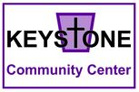

Keystone Community Center Merchandise
*Contact the center if you’d like to purchase any item!

T-Shirts: $10.00

Tote Bags: $5.00

Calendars: $10.00
*won’t be available until Jan 2023

Mugs: $8.00

Hats: $10.00

