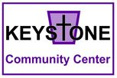
Keystone Community Center
Current Physical Needs List

1. Step2 KidAlert V.W.S. Safety Sign or other children safety road signs
2. Two to three patio tables with umbrellas and benches/chairs
3. Shelving for canning supplies
4. Small wheelbarrow
5. Bags of dirt for garden
6. Garden Tools
7. Planter boxes

A Few Things to Keep in Mind:
- We update this list frequently as needs come and go.
- Different needs arise often depending on the time of year.
- If you plan on fulfilling a need, please contact the center immediately.

